**Procedure for checking & backup of UPS System BF1, BF2, HBS1, HBS2,BF2 baghouse, Overhead & LAB**

**Objective:** checking and backup of UPS System in BF1, BF2, HBS1, HBS2, BF2 baghouse, Overhead & LAB

.

**Scope:** Applicable for UPS System in in BF1, BF2, HBS1, HBS2, BF2 baghouse, Overhead & LAB.

**Reference: RISK/INST/07 & HIRA /INST/07**

**Performance Criteria** : Healthiness of redundant ups system and online

**Aspect for the Activity** : NA

**Identification of Hazards:**

**Physical:** Electrical Shock.

**Mechanical:** Trip & Fall

**Chemical:** Dust

**Ergonomics:** Insufficient work practices

**Hazard due to Human Behavior/Human error:** Not adhering to WI/ PPE, Alcoholism , Use on non-certified tools/equipment.

**Responsibility** : Sr. Engineer Instrumentation/Associate / Inst Technician

**Procedure:**

All engineers and technicians shall follow this procedure whilst checking and changeover of APLAB make UPS System in BF1 & BF2

**PROCEDURE FOR BF1 & BF2 APLAB UPS :**

For checking and changeover of APLAB make UPS System in BF1 & BF2

1. In BF1 and BF2 for PLC system APLAB make 3KVA Hot Redundant UPS system is in place.
2. Each UPS has 15 nos of battery bank, each battery rated 12V, 26AH.
3. The O/P to PLC is going from UPS 1 and UPS 2 is always in standby mode.
4. The O/P of UPS 2 is connected in auxiliary bypass of UPS 1. In case UPS 1 fails to give O/P then O/P will go from UPS 2 through auxiliary terminal of UPS 1.
5. The incoming supply of UPS 2 is looped in auxiliary bypass of UPS 2. In case UPS 1 and UPS 2 both fail then auxiliary bypass supply of UPS 2 will feed power to PLC system through auxiliary bypass terminal of UPS 1.

**Change over and back up procedure**

* Put off the mains of UPS1 and check the battery backup for minimum of 15 min.
* Put off the inverter of UPS 1, the load should changeover to UPS2
* Put off the mains of UPS 2 and check for battery backup for minimum of 15 min.
* Put on the mains of the UPS 2 and UPS 1 and inverter of UPS 1.
* For transferring the load back to UPS 1 need to press load transfer button of UPS 1. After pressing the load will be transferred from UPS 2 to UPS 1. Check the load at display of UPS 1

**PROCEDURE FOR HBS1 & HBS2 HITACHI UPS:**

For checking and changeover of HITACHI make UPS System in HBS1 & HBS2

1. In HBS1 and HBS2 for PLC system HITACHI make 7KVA parallel 2UPS system is in place.
2. Each UPS has 26 nos of battery bank, each battery rated 12V, 26AH.
3. O/P L1 & O/P L2 are short linked and O/P N1 & O/P N2 are short linked , ALT L1 & ALT L2 are short linked and ALT N1 & ALT N2 are short linked.
4. Main bypass supply is connected to UPS 2 ALT L2 & ALT N2 and Bypass supply is given to UPS 1 from UPS 2 ALT L2 & ALT N2
5. The O/P to PLC is going from UPS 2.
6. The O/P of UPS 1 is connected to UPS 2 O/P L1 & O/P N1
7. Incase if UPS2 Inverter fails the Load of UPS1 will get transferred to UPS1 and O/P to PLC will go from UPS2 O/P L2 & O/P N2,The Communication cable connected behind the UPS should be healthy.

**Change over and back up procedure**

* Put off the mains of UPS1 and check the battery backup for minimum of 15 min.
* Put off the inverter of UPS 1, the load should changeover to UPS2
* Put off the mains of UPS 2 and check for battery backup for minimum of 15 min.
* Put on the mains of the UPS 2 and UPS 1 and inverter of UPS 1.
* For transferring the load back to UPS 1, One need to select the Parameter on Display and with UP/DOWN arrow go to Control in Control Inverter ON Option is there you need to Press Enter load will be transferred from UPS 2 to UPS 1. Check the load at display of UPS 1

**MAINTENANCE PROCEDURE & WORKING FOR BF2 BAGHOUSE, OVERHEAD & LAB UPS:**

* Inform the Lab In charge for Lab UPS maintenance and for BF2 Baghouse & Overhead Ups Inform BF SS.
* Take Work permit while working on UPS.
* Switch OFF the Inverter by pressing the Button from the front panel of UPS.
* Switch OFF the Mains Supply of UPS.
* Switch OFF the Battery MCB from the UPS back panel.
* Clean the UPS with Vacuum Cleaner/Blower
* Check all the Power circuit & Control circuit cable connection & tightness.
* Check the Fuse of Power devices.
* Check AC capacitor with Multimeter.
* Check all the control card healthy conditions.
* Switch ON Main supply, after Display is ON wait for 5 Min and Switch ON the Inverter and then Switch ON the battery MCB.
* Switch ON Load MCB
* Then Put OFF main input supply for checking the battery backup, After 30 min Check individual battery voltage and note the readings.
* Then Switch ON Mains Input Supply

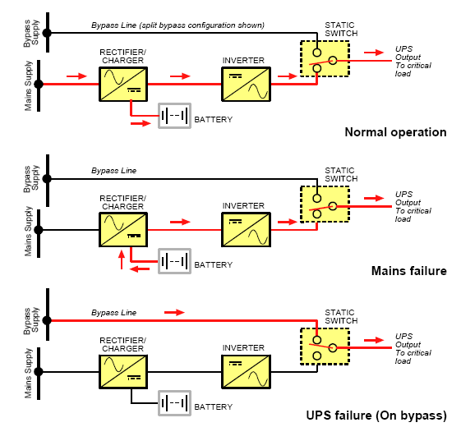

**Amendement Record**

|  |  |  |  |
| --- | --- | --- | --- |
| **Date** | **Manual Section Ref. & Para** | **Brief details of Revision** | **New Rev.** |
| 13.09.2023 | Objective | Added BF2 Baghouse & Overhead UPS | 03 |
| 13.09.2023 | Scope | Added BF2 Baghouse & Overhead UPS | 03 |
| 13.09.2023 | Procedure | Added BF2 Baghouse, Overhead & LAB Ups | 03 |
|  |  |  |  |

|  |  |  |
| --- | --- | --- |
| **Prepared By:**  Head Instrumentation PID1 | **Reviewed & Issued By:**  Management Representative | **Approved By:**  Head – Electrical & Instrumentation PID1 |
| **Signature:** | **Signature:** | **Signature:** |
| **Review Date:** 13.09.2023 | **Review Date:** 13.09.2023 | **Review Date:** 13.09.2023 |
|  |  |  |